Step for downloading App on your desktop

- Open the “App” folder

App
- Click on ‘APP_pkg’ and follow the instruction to install to install the MCR 7.15 installer (embedded inside) . After installation complete, you will see the following icon.
- Right click on the icon and select “Run as administrator’.

App
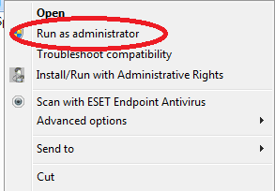

- You will see the following screen App (blank displays)

- Before start counting (always), enter Reader ID, Case ID #, Platform and Stain information in the upper right corner display.

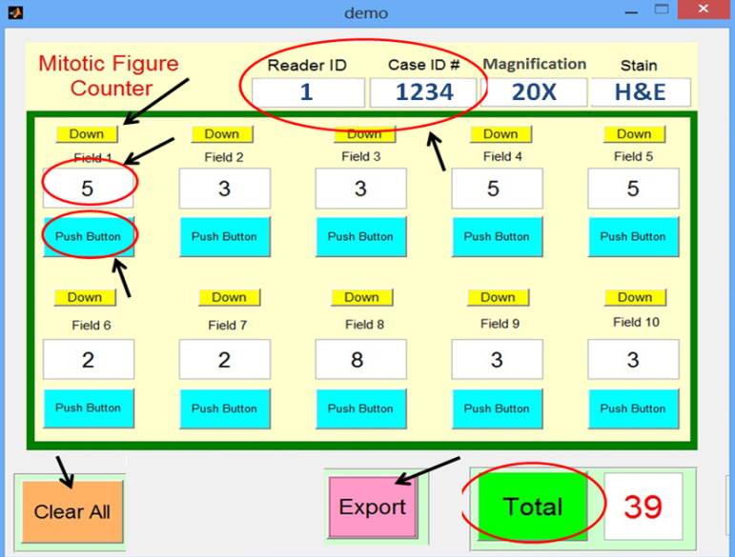

- To start counting, for first count, enter ‘1’ (using keyboard) in the display (below Field 1)
- Use push button (below Field 1 display) to increment the counts.
- Use ‘Down’ button if you accidently counted wrong event for decrementing the count by ‘1’.
- Move for ‘Field 2’ and so on up to Field 10.
- After counting all the Field`s count, press ‘Total’ button to get the total.

- Don`t press ‘Total’ button in between; it will only work if all displays (Field1-to-Field 10) are filled with numbers.

- Press ‘Export’ button to record the data in the excel file named as ‘Book1.xls’ (already added into the ‘App’ folder. The data will be automatically recorded in ‘Book1.xls’
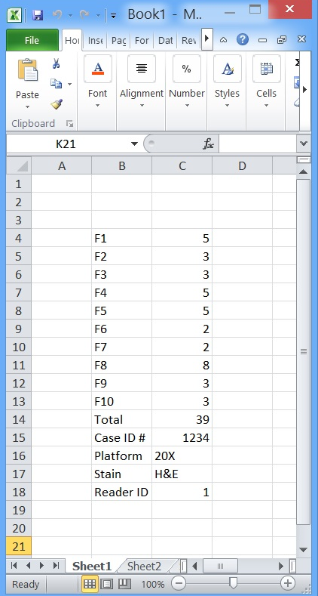

(a) Keep excel file ‘Book1.xls’ closed while pressing export button, otherwise it will not
record your data

(b) Don`t create any new excel file or move out from folder. Don`t change the name of excel file. It is set as ‘Book1.xls’. Place all files in the ‘APP’ folder.

- Press ‘Clear All’ button to clear the previous data and to start new counting. Again start with First step by recording ‘Case ID #’, ‘Platform’ and ‘Stain’
- Before start opening next case, you can open excel file’Book1.xls’ in the App folder to see your recorded data. Close this file before starting new counting.

