ITCR Training and Outreach Working Group Meeting

Thursday, June 13, 2019
4:00 - 5:00 PM Eastern Time

Agenda

- ITCR announcements
- Looking for a Training and Outreach Co-Chair (any volunteers)?
- Poster presentations: Poster are a key mechanism for performing Outreach at meetings. What makes for a good/effective poster? In this meeting we will discuss best practices for poster design.
  - Homework assignment: Watch this 20 minute video: How to create a better research poster in less time (the video is also an excellent example of an ‘Explainer Video’. See here and here for prior meeting notes on explainer videos). Also, see this link for a commercial company that may be able to make scientific explainer videos if you have any $$ to spend: https://sciani.com.
  - Guest speaker and roundtable discussion with Mike Morrison (@mikemorrison), the creator of the youtube video listed above. Mike will discuss his ideas on poster design as well as his tips for making the excellent explainer video. Mike has a template for his poster design.

Brief Bio: Mike Morrison is a former User Experience (UX) designer who quit his tech career to become a PhD student in Work Psychology. Generally, he is trying to do three things in his career: 1) Bring User Experience design principles to science, to help scientists learn and disseminate insight faster and more efficiently 2) Understand the factors that make work meaningful (or meaningless). 3) Study the psychological differences between so-called ‘realists’ and ‘dreamers’. Accomplishments so far: In his former career, he helped create software used by over a quarter-million people, and created online communities that reached hundreds of thousands of people. Since starting his PhD, he has given talks on the future of work, meaningful work, translating science for the public, and the future of Open Science. He also recently released a YouTube cartoon proposing a new way to design scientific posters, which went viral, and has now encouraged researchers across science to try a different approach to their conference posters, often with great success.

Twitter: https://twitter.com/mikemorrison

Also see: Article and Audio Interview on NPR

Daily briefing: How to build a better scientific poster - (Nature)

Research Presentation Guide Goes Viral (MSU News)

Example poster design template:

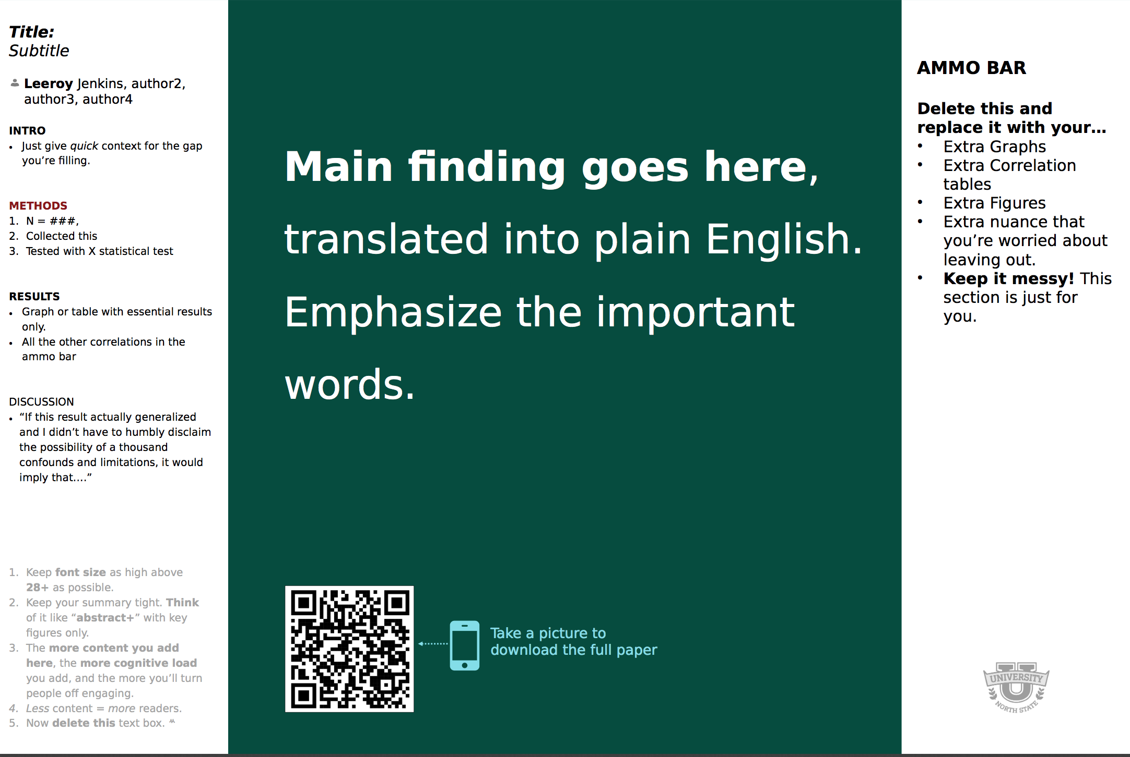

Upcoming Meetings

July 2019: topic TBD

Webex Information:

JOIN WEBEX MEETING
https://cbiit.webex.com/cbiit/j.php?MTID=m90b62cf4b0ffc9b0c9e13b53425cc602
Meeting number (access code): 733 094 302

JOIN BY PHONE
1-650-479-3207 Call-in toll number (US/Canada)

Global call-in numbers:
https://cbiit.webex.com/cbiit/globalcallin.php?serviceType=MC&ED=574640482&tollFree=0

Prior Meeting Notes: NCIP Hub

Feedback about meeting or suggestions for future meetings: Anonymous Qualtrics Survey

Outreach Activities Since Last Meeting (please fill in with new rows)
Name | Tool | Description of Activity
David Hanauer | EMERSE | Demo for Cleveland Clinic Taussig Cancer Center
Tali Mazor | cBioPortal | Demo for (1) Harvard Program in Therapeutic Sciences postdocs and (2) Count Me In team
Michael Reich | GenePattern Notebook | San Diego Jupyter Meetup talk
Michael Reich | GenePattern Notebook | GenePattern RNA-seq analysis, Boston University, workshop
Michael Reich | GenePattern Notebook | Applications for Analysis and Modeling in Single Cell Genomics conference, UC Irvine, 2 posters

Attendees, please sign in here:
David Hanauer, U of Michigan
Michael J. Becich, University of Pittsburgh School of Medicine
Bradley Broom, UT MD Anderson Cancer Center
Mary Goldman, UC Santa Cruz
Hayley Dingerdissen, GW
Mervi Heiskanen, NCI
Jeremy Warner, VUMC
Martin Morgan, Roswell Park
Tali Mazor, DFCI
Mike Ryan, JHU / MD Anderson
Michael Reich, UCSD
Simina Boca, Georgetown University
Amanda Bell, GW
Emilie Roncali UC Davis

Minutes (everyone feel free to contribute):

https://dribbble.com
http://betterposters.blogspot.com/
https://www.fiverr.com

